THE NILGIRIS EQUESTRIAN CHALLENGE APRIL 2016

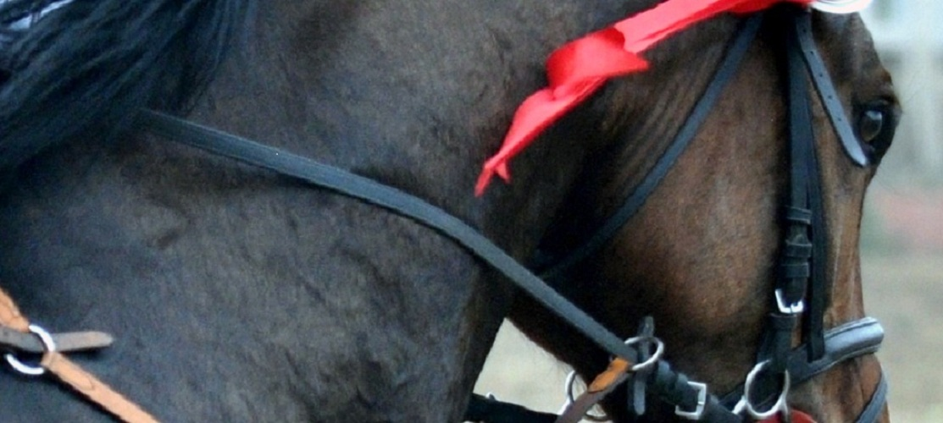
Hold your horses…
The Equestrian Challenge is back!
“If on earth there exists a paradise; tis’ on a horse’s back it lies!”

Carrying the legacy forward
The Nilgiris have always had a rich tradition of the Equestrian sport. Horse Shows were traditionally held in the Wellington Gymkhana club every year. Ooty also has the only active hunt club this side of the Suez. Unfortunately the Horse Show has been discontinued in recent years. The Race course in Ooty has a regular season from April to June where racehorses come up from Chennai and other centers. We plan to revive equestrian sports in the Nilgiris by holding The Nilgiris Equestrian Challenge annually from 2016 and subsequently more events like the National Equestrian Championship (NEC).
The Equestrian scenario in India has undergone tremendous improvement with the import of a large number of European Sport horses also known as ‘Warm Bloods.’ As a result, the standards of Show Jumping and Dressage have surged upwards. Most of the horses participating in the show will be Warm Bloods. A number of European professional riders will also be in action along with the best in India.

We would love to see you all in action

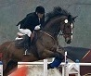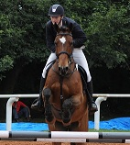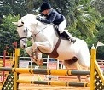
Sandeep Dewan
Marie Lucas
Guillaume Marcotte

To hold an event of this magnitude over a period of 2 weeks the organizers are incurring considerable expenses for stabling of participating horses; travel, board and lodge of judges; making of ground infrastructure, audio, lighting etc.
The organizers will host a welcome party and a Horse Show Ball at premium locations. We are also holding Feature Events - competitions like the 6 bar/ Top Score/ Puissance/successive relay. Prize money will be given for most events.
We hope there will be support and participation from all the top clubs in South India like the Embassy International Riding School, Bangalore; Equestrian Centre for Excellence, Bangalore; Sethalwad Equestrian Centre, Bangalore; Team Marcotte, Bangalore; Chennai Equestrian Centre, Chennai; My Pony Club, Chennai; Red Earth Riding School, Pondicherry; Alexander Equestrian Club, Coimbatore; Hyderabad Polo and Riding Club, Hyderabad amongst others.

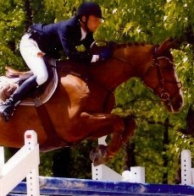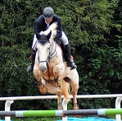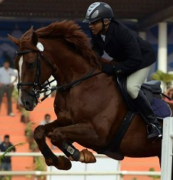
Gregory Lassus
Nitin Gupta
Aditya Krishna
A spectacular venue
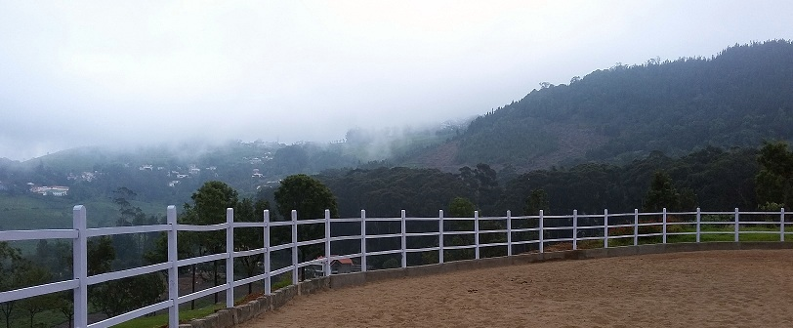

The show is being organized by the Radiance Highfield Equestrian Centre which is located in the serene and picturesque Highfield Tea Estate in Coonoor.
The event will be held from Friday 29th April 2016 to Sunday 8th May 2016.
Our unique show ground crowns the top of a hill and affords one a spectacular 360 degree view of the beautiful mountains and tea estates. You will enjoy the clean crisp air and pleasant weather far away from the heat and dust of the plains!
Especially for you
We understand and appreciate the time, effort and money that each of you will be spending to attend the show; hence we have ensured that there will be prize money for most events as stated in the schedule of events below.

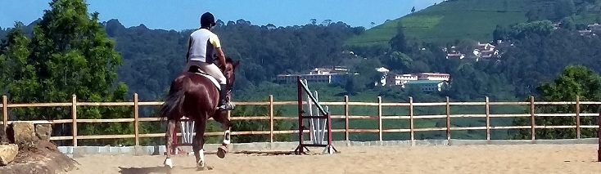
The Schedule
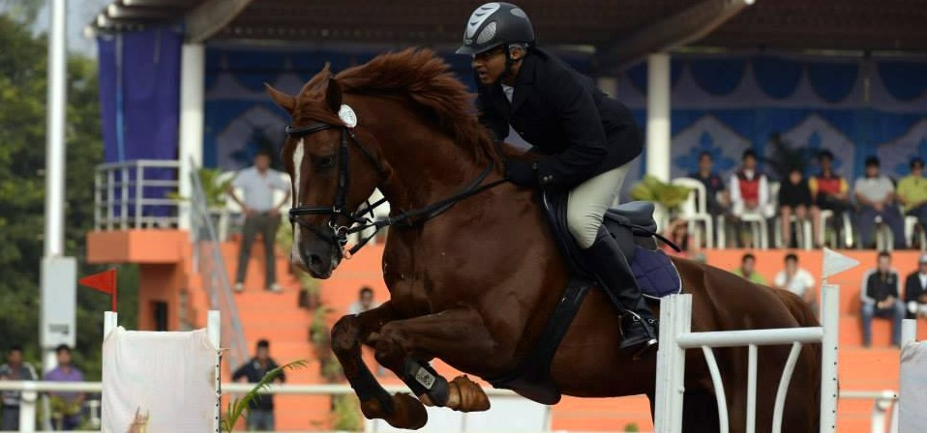

Friday 29th April 2016
SJ 1: 60 to 70 cm. Table “A” with Jump-off.
SJ 2: 90 cm. Table “A” with Jump-off.
SJ 3 : 100 cm. Table “A” with Jump-off.
SJ 4 : 120 cm. Table “A” with Jump-off. (7K, 5K, 3K = Rs 15000)

Saturday 30th April 2016
SJ 5 : 65 to 80 cm. Table “A” with Jump-off.
SJ 6 : 105 cm. Table “A” with Jump-off.
SJ 7 : 110 cm. Table “A” with Jump-off. (5K, 3K, 2K = Rs 10000)
SJ 8: 130 cm. Table “A” with Jump-off. (10K, 5K, 3K = Rs 18000)

Sunday 01st May 2016
SJ 9: 90 To 110 cm. Jumping Top Score. (5K, 3K, 2K = Rs 10000)
SJ 10: 80 to 90 cm. Table “A” with Jump-off.
SJ 11: 115 cm. Table “A” with Jump-off. (6K, 4K, 2K = Rs 12000)
SJ 12: 90 To 110 cm. Show Jumping successive relay teams of two riders each.
SJ 13: Six Bar. Feature Event. (15K, 10K, 5K = Rs 30000)

Tuesday 03rd May 2016
Preliminary Dressage. (5K, 3K, 2K = Rs 10000)

Wednesday 04th May 2016
Medium Dressage. (6K, 4K, 3K = Rs 13000)

Thursday 05th May 2016
Elementary Dressage. (7K, 5K, 4K = Rs 16000)

Friday 06th May 2016
SJ 14: 60 to 70 cm. Table “A” with Jump-off.
SJ 15: 90 cm. Table “A” with Jump-off.
SJ 16 : 100 cm. Table “A” with Jump-off.
SJ 17 : 120-130 cm. Table “A” with Jump-off. (10K, 5K, 3K = Rs 18000)

Saturday 07th May 2016
SJ 18 : 80 to 90 cm. Table “A” with Jump-off.
SJ 19 : 90 to 105 cm. Table “A” with Jump-off.
SJ 20 : 110 cm. Table “A” with Jump-off. (5K, 3K, 2K = 10000)
SJ 21: 130 To 140 cm. Table “A” with Jump-off. Feature Event. (15K, 10K, 5K = Rs 30000)

Sunday 08th May 2016
SJ 22: 60 to 70 cm. Table “A” with Jump-off.
SJ 23: 80 to 90 cm. Table “A” with Jump-off.
SJ 24: 115 cm. Table “A” with Jump-off. (5K, 3K, 2K = Rs 10000)
SJ 25 : 90 to 110 cm jumping Knock-out. (5K, 3K, 2K = Rs 10000)
SJ 26: Puissance. Feature Event. (15K, 10K, 5K = Rs 30000)
Note:
- All Show jumping events up to 1.30 m will also be Team Events. Participants/clubs may enter teams of 3 riders each.
- Dressage tests will be forwarded shortly.
- Entry fee is Rs 500 per individual entry and Rs 1500 per team.
- Entries will close on Wednesday the 27th of April 2016. Entries received after that will be treated as post entries and will be Rs 1000 per individual entry and Rs 3000 per team.
- A detailed schedule with times will be prepared and forwarded closer to the dates.
- The program is subject to change by the organizers depending upon entries received and other administrative reasons.
- The prize money amounts may vary at the discretion of the organizers depending upon number of entries received in each event.
“No hour of life is wasted that is spent in the saddle.” – Sir Winston Churchill

